Creating applications for iOS

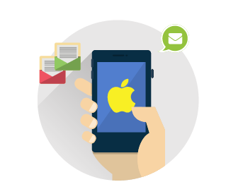
Digital agency GATEON is engaged in application development for iOS since 2008. Due to our extensive knowledge and many years of experience in App Development, we learned how to make simple and complex applications for iPhone, iPad and Pocket PC with iOS and MAC operating systems of different versions.

Close cooperation with marketers and usability experts allowed to get deep understanding of the users’ needs, we know how to make an application as efficient as possible.

Your ideas are the "soul" of the application. After listening to your wishes we study the target audience, learn how they formulate queries, then analyze similar applications in App Store. What do users lack? The answer to this question will be your competitive advantage.

Everything should be well-thought-out and documented before experts set to work: designers draw the layout, developers turn it into a finished product. Code is being written in Swift or Objective-C programming languages with using both proven and newest technologies.

We understand importance of meeting deadlines, that’s why we provide progress reports at each development stage.
In order to ensure that the new application works fine, we conduct manual and automated tests, after which we place the application in the AppStore for free.

As a result, you get a quality iOS application with a user-friendly interface and attractive design that meets Apple's standards and usability.

Even when the project is successfully launched, we provide technical support, as well as regularly updates for new iOS versions.

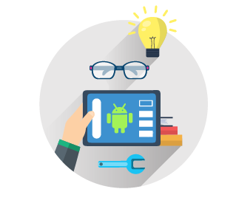
Creating applications for Android

Application for Android OS opens additional opportunities for your business. While others are just learning cross-platform technologies, you have a unique chance to break into the tops and make a powerful leap into the world of Android, where 1.4 billion active users live.
The team "GATEON" converts them into your customers. Being an experienced player in the arena Android-applications building for smartphones, tablets and Pocket PCs, we provide necessary support at any stage of development.
The way to the hearts of customers is through the satisfaction of their needs, so we always start working with market research, learning of competitors, target audience and their preferences. Describe what business tasks your application should solve, and we'll figure out how to implement it.
In the working process your ideas turn into prototypes of the main pages, and then take shape in mock-ups, drawn by the best designers. Visual C #, Visual C ++ and JAVA are programming languages ​​used in the development for Android.
Android application development is different from iOS, but usability laws are always the same. Intuitive design, adapting to any device model and screen resolution, convenient layout of menus and buttons - all this will be taken into account when creating the application.
Quality control is the steady principle of our work. We publish applications only when we are absolutely sure that everything works correctly and meets the standards. After launch we continue to support your project.
We are interested in your success, therefore we guarantee a highly effective result in a short time, in accordance with our commitments.

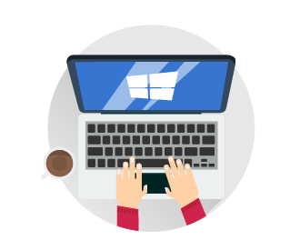
Creating applications for Windows

Digital agency GATEON is one of the few companies creating applications for Windows operating systems. We undertake projects of any complexity and demonstrate consistently high quality of products and services.

Windows applications for business, e-commerce, entertainment and multimedia, news and educational applications - we can do everything with pleasure. We invite you to check it.

Key feature of Windows Phone applications - to adhere to style Metro: graphic minimalism, readability, smooth animations, flat rectangular tiles. The main idea of ​​Metro is the focus on the text, which fits easily into the mobile design concept, where readability and easy navigation are also important.
By entrusting us to develop an application for Windows, you can be sure that it will be made in accordance with Microsoft Store standards.
We do not just create an application, but convert your ideas into a result that brings real income.

Creating Web Projects

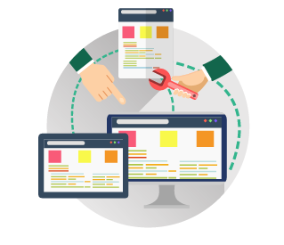
Web projects development of is our main specialization.

Do you want to create a one-page landing page, corporate website, online store, web application, social network, forum or intranet system for Business process automation?

We can do projects of any complexity - everything that you can imagine and describe to us.

In the process of creating any project, we pay special attention to design. Our team employs professional web designers with many years of experience to develop unique graphical interfaces, draw details, create animations and effects. Technical part of the work includes web programming and configuration both on the client side and on the server side.

Comprehensive approach is at the heart of our activities, based on four web-development whales: a strong concept, beautiful graphics, convenient navigation and advanced technologies allowing you to solve the tasks effectively.

Design, 2D, 3D modeling
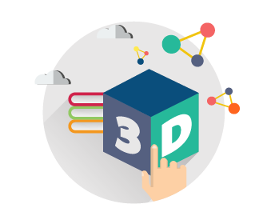
Design is worthy of special attention. We always come with awe to it, like an inspired artist who peers into a clean canvas, imagining what his picture will be. The picture is designed to evoke emotions in a viewer, the task of website design is to form a positive image.

Good design inspires admiration, cuts into memory, encourages visitors to act and come back again and again. Have you ever heard the expression "Wow-effect"? We are aiming for it.

Design begins in a dialogue with a client. In many respects, tasks assigned to the site by you determine direction of designer's thoughts. A layout of the car parts store is different from a layout, for example, the catalog website of a well-known brand. For the first website it is advisable to focus on the information side, task of the second one is to touch the heart with its artistic content.

Some sites require more detailed elaboration of details than usual. For example, to attract buyers of cosmetics or clothes, we must show the goods from all sides, invite them to mentally "try them on". These tasks are successfully being solved by 2D and 3D modeling. We have a colossal amount of work to do: to think about color combinations, sizes and colors variants, as much as possible coinciding with the original product, and also to emphasize advantages, to pay attention to pleasant trifles, accessories, materials.

When the site functions meet users’ needs, the latter reciprocate. Having done a marketing research, we will determine which design suits your target audience and, depending on its preferences, we will select the most effective design.

No matter how difficult the tasks may seem, if you choose us for creating a design, we will show you that nothing is impossible. The key to success for us is golden mean principle: a competent combination of information and image components.

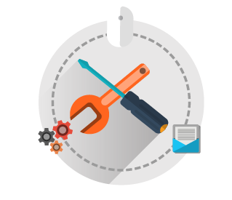
Further development and technical support
Even after successful launch, the site needs attention. Over time, there may be different situations requiring prompt action. We recommend to take care of this in advance and appoint someone who will be involved in development and maintenance of your site.
Sometimes help is needed urgently: errors on the site, long loading or hosting payment missed - at this time you can lose valuable customers. It's good to have digital portal "Gateon" at hand, which instantly comes to the rescue, reanimates, corrects errors and optimizes website’s work.
Website appearance, functionality and content also inevitably lose relevance. To remain in good standing with customers and search engines, you should regularly update the design, functionality, and rewrite texts.
By giving the site to us for service, you will save a lot of time and money, because all the routine work will be gladly performed by our specialists.

SLIDER
Website development
Digital agency "Gateon" creates websites of any complexity in a short time, working in a team with the best developers, designers and testers. Your project will be managed by your personal manager.
Web design and layout
Beautiful website design made by "Gateon" can become a solid advantage. We develop web interfaces on any topic, taking into account customers’ wishes and marketers’ recommendations. We create websites better than your competitors’ websites.

Project management
After the launch of your new website we will fill it with content, offer ideas for further development. Thanks to the proper organization of information and successful positioning, your site will be able to take your business to a new level.
Optimization and Promotion
In order to improve your site's search ranking, we use internal and external SEO optimization. Only legal, "white" promotional methods are used, based on Yandex, Google or Yahoo recommendations. Thus, our agency guarantees successful getting into the TOPs on relevant requests and keeping the website positions for a long time.
About company

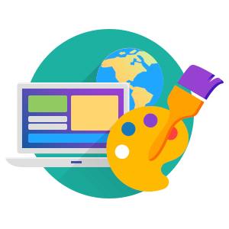
Digital agency GATEON has been operating since 2008
For more than 10 years our company has been providing full range of services: from project development to its promotion in Internet. We successfully design and develop business websites, landing pages, online stores, catalogs, portals and all sorts of web and mobile applications on any topic.
In addition to prompt technical support, our customers get assistance in content filling, SEO optimization and promotion. Many clients sign yearly website maintenance contracts with us.

Our partners are successful businessmen, heads of companies in different industries
Majority of them are regular customers who appreciate benefits of working with us and regularly come with new projects.
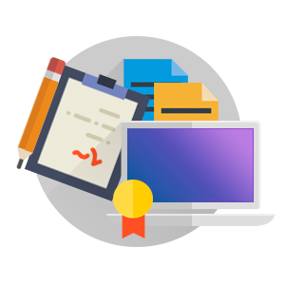
Staff of the digital agency GATEON consists of
specialists with rich experience in web development, programming, web and graphic design, advertising, SEO optimization and SMO promotion.
Due to successful management system and well-coordinated work of each employee, we make impossible things possible, and turn months of development into weeks.
As a result, we can proudly say that we really do provide high-quality service, and we are happy to demonstrate it.
Flexible conditions for cooperation, quality assurance and compliance with deadlines
allows us to build trust relationships with each customer. Depending on your preferences, we can offer several payment options: partial prepayment (50%), full prepayment (100%) or payment upon completion.
There are no geographical borders for us because we work with all countries supporting more than 50 payment methods: Cash, Credit Cards, Visa, Mastercard, Webmoney, PayPal, Payoneer, Yandex.Money, Kiwi and many others.

